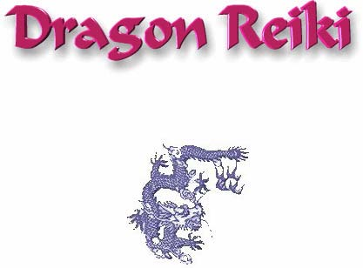

**Dragon Reiki is a Scared True Mystery School!**

**Maybe one of the most important ENERGY Systems of 0ur time.**

**Scared Oath Below:**

**I Agree on my Sacred Oath Never to reveal anything to anyone ever about Dragon Reiki. I know there are NO master levels.**

**Sign Below:**

(........................................)

and email to:

[shantivictor@gmail.com](mailto:shantivictor@gmail.com?subject=Oath)